PFC - Assignment – part 2
Income tax bill and summary report
As your second assignment in this semester, you are to upgrade your Income tax program to accommodate an Income tax summary report.

Learning Outcome
Upon successful completion of this assignment, you will have demonstrated the ability to use one-dimensional array data structures.

Specifications
In the previous assignments we consider only personal tax information for one person. In this one you should use array to store data for employees in a company. Two more data items are added to personal tax information: code and name. When running your program displays the menu as below:

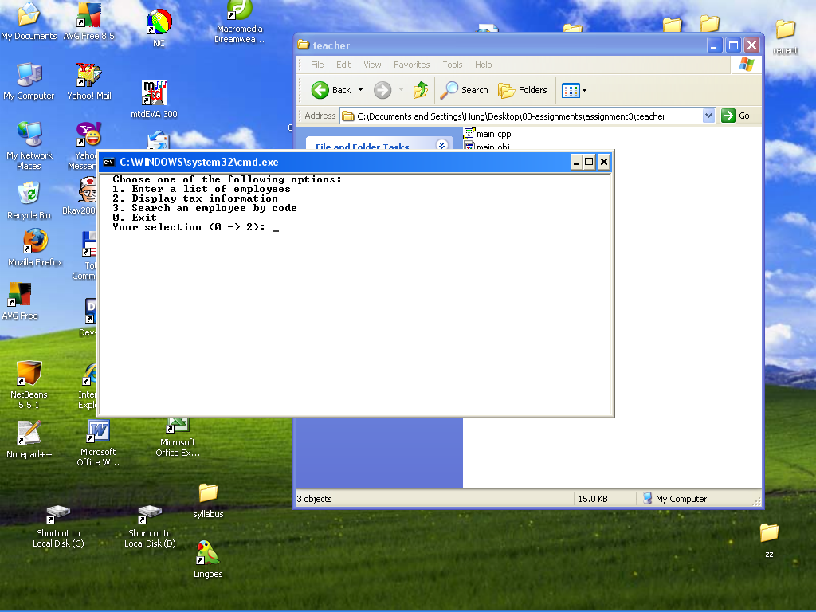
You can select the option 1. to enter data for employees. Beside keeping data validation as before, your program should check the entered code to be sure that it does not exists in the list.
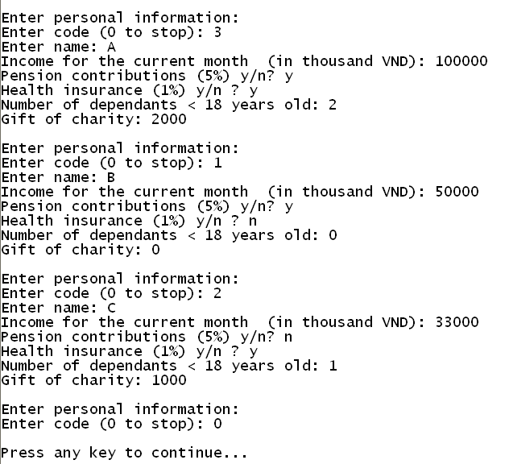

When you select the option 2., the program displays summary report like the following.

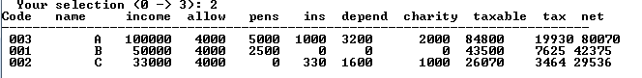
When you select the option 3 and enter the code to be searched, the the program displays the output like the following.
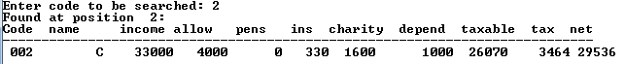

You can run the tax2.exe file to know how the program should work.

Submission Requirements

At the beginning of your program, include comments reflecting accurate information for you in the format as below:

/*
Assignment 1 - Income tax
Class ID : SE0424
Student ID : 00400
Student Name : Nguyễn Minh Đức
Due Date : 12 February 2009
I declare that this assignment is my own work
in accordance with FPT Policy.
*/

